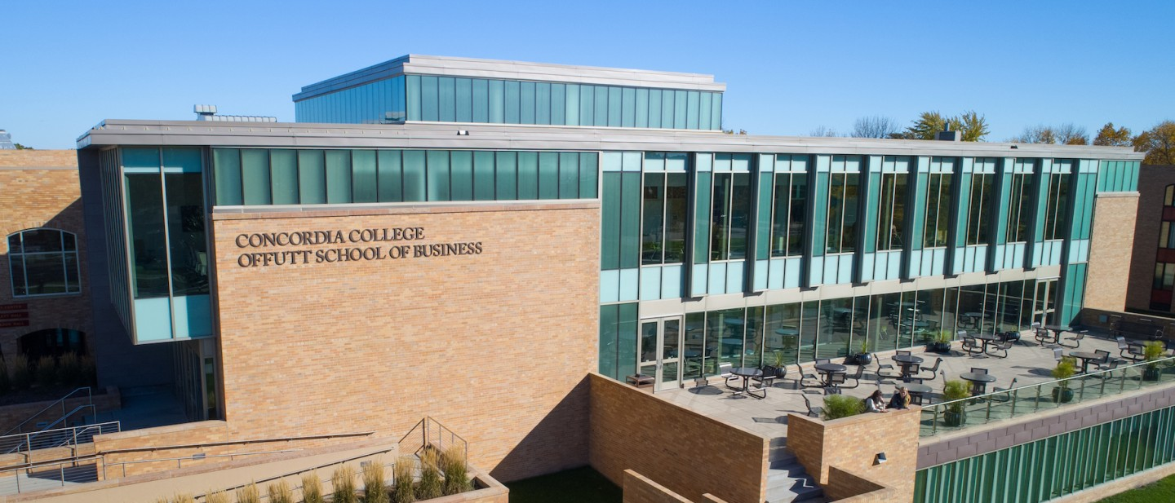

Project Proposal

|  |
| --- |
| SOLITAIRE |

|  |  |
| --- | --- |
| Course | **CSC 225 – Fundamental Structures** |
|  | |
| Team Name | **TEAM X** |
|  |  |
| Team Members | **Ana Aguilar** |
|  | **Brook Gebreeyesus** |
|  | **Kelly Pudwig** |
|  | **Zamzam Mohammed** |

|  |
| --- |
| Executive Summary |
| **Your executive summary should resemble an elevator pitch: your motivation is to quickly persuade a decision maker to get involved in your project.**  **What is the purpose of your project? What problem(s) does it address?**  **Why is your project important? Why is it relevant?**  Solitaire. The purpose of this game is being a de-stresser and a way of combatting boredom. It is a simple game with simple rules, but still has the advantage of “exercising” the brain. |

|  |
| --- |
| Background and Problem History |
| Explain the problem domain and relevant background information about your project.  Provide a brief history of the problem; when did it start? What attempts have been made to solve it?  Everyone has daily life stressors and periods of time with nothing to do. Both of these extremes are a source of anxiety for people, and not having an outlet for these negative emotions can easily make someone’s mind spiral into distress.  As we all know, this is what games aim to combat. They give people something to do that is not stressful or feels like a chore, it is literally playing. But just like Solitaire, many games strive to also give some kind of extra benefit, to exercise the mind and/or body. |

|  |
| --- |
| Solution |
| How does your team plan to solve the problem?  What makes your approach different from other solutions?  By making Solitaire we aim to have an easy-to-understand game, that can be both calming and challenging. Add things such as time limits, special rules, and high scores so people can really get into the game. If possible, it would also be beneficial to implement “themes” for the cards in the game; have standard cards, black cards, colorful cards, etc. |

|  |
| --- |
| Project Deliverables |
| What will be the “product” of your team’s project? What documents will you create?  .exe = The actual game file.  README = Game instructions or just a thank you note  .java or other code file = Code file so people can check on the code that is being used (class feedback) |

|  |
| --- |
| Success Criteria |
| How will your team define success? What aspects of your project can you quantify to objectively measure success?  Have a completed Solitaire game application. It should have no glitches or bugs (like cards disappearing or the player getting soft locked because they did a wrong move, things of that sort). It also should have options of restarting the rounds or exiting, and once there are no possible moves to be made to have a message that alerts the player of this (a.k.a. they lost the round). |

|  |
| --- |
| List of Required Project Resources and Materials |
| What resources (books, websites, data sets, problem domain information sources, software, etc.) will be required to complete your project?  Netbeans  Websites (such as Stack Overflow)  Some help from the book  Solitaire game rules (just the standard rules of the game and maybe game modes) |